Educating Professional Opportunities among Eklavya School Girls.

Action Research Report

Investigator
M.Mahalakshmi
Lecturer,
District Institute of Education and Training,
Uthamacholapuram, Salem-10.

Submitted to
STATE COUNCIL OF EDUCATIONAL RESEARCH AND TRAINING, CHENNAI-6.
2023-24

M.MAHALAKSHMI
LECTURER,
District Institute of Education and Training,
Uthamacholapuram, Salem-636 010
This is to certify that the action research entitled as “Educating professional opportunities among Eklavya School girls” is an original work of Mrs.M.Mahalakshmi, Lecturer, District Institute of Education and Training, Uthamacholapuram,Salem during the year 2023-2024 and not from any part of previous work.

Place: Salem Date:
M.Mahalakshmi

Principal
District Institute of Education and Training,
Uthamacholapuram, Salem.

Acknowledgement

I wish to express my gratitude to the Director, the Joint Director, SCERT, Chennai for permitting me to take up this Action Research and granting financial assistance to carry out this work.

I extend my sincere thanks to Dr.A,Ramesh, Principal, District Institute of Education and Training, Uthamacholapuram, Salem for rendering his support and guidance.
I rendered my sincere thanks to Dr.M.Selvam, Principal, District Institute of Education and Training, Namakkal for his support and guidance.
I wish to record my sincere and whole-hearted thanks to the Head Master and teachers of Eklavya Residential Hr sec school, Yethapur, Pethanayakkan palayam, Salem District.
I also owe my thanks to the faculties of District Institute of Education and Training, Uthamacholapuram, Salem who collaborated with me and helped me to complete my research work.

CONTENT
S.NO | TITLE
1 | Introduction
2 | Significance of the study
3 | Statement of the problem
4 | Objectives of the study
5 | Probable cause for the problem
6 | Action hypothesis
7 | Sample
8 | Tools
9 | Activities
10 | Statistical Analysis and Interpretations
11 | Findings of the study
12 | Recommendations
13 | Conclusion
14 | Annexure
15 | Module

I.INTRODUCTION
The term women empowerment is all about authority, or the power embarked on women sharing indistinguishable rights. The term refers to the liberation of women from socio-economic restraints of reliance. Women comprise around 50% of the country’s population, and a bulk of them stays economically dependent on each other without employment. In the age of feminism, a small portion of women in India are freed and can employ their free will and are permitted to carve out their lives the way they want. But there is a considerable division of the women in this nation who require optimistic support. In most Indian villages and semi-urban cities, women are still denied fundamental education and are never authorized to continue higher education despite amassing the understanding required.
Women are known for delivering multiple roles effortlessly per day, and thus, they are considered the backbone of every society. Living in male-dominating societies, women play a wide range of roles, such as caring mothers, loving daughters, and capable colleagues. The best part is that they fit the bill perfectly in every role. Nonetheless, they’ve also stood as a neglected bunch of society in different parts of the world. In turn, it has resulted in women surviving the brunt of unevenness, financial trustworthiness, oppression, and distinct social evils. So, it is essential to give proper support and guidance to the girl children to develop professional skill. Empowering women is essential to the health and social development of families, communities and countries.
When women are living safe, fulfilled and productive lives, they can reach their full potential. contributing their skills to the workforce and can raise happier and healthier children. They are also able to help fuel sustainable economies and benefit societies and humanity at large.
A key part of this empowerment is through education. Girls who are educated can pursue meaningful work and contribute to their country’s economy later in life. They are also four times less likely to get married young when they have eight years of education, meaning that they and their families are healthier.

II. Significance of the study
Women’s empowerment can be defined to promoting women’s sense of self-worth, their ability to determine their own choices, and their right to influence social change for themselves and others.
It is closely aligned with female empowerment – a fundamental human right that’s also key to achieving a more peaceful, prosperous world.
Women’s empowerment and promoting women’s rights have emerged as a part of a major global movement and is continuing to break new ground in recent years. Days like International Women’s Empowerment Day are also gaining momentum. But despite a great deal of progress, women and girls continue to face discrimination and violence in every part of the world.
To understand the value of women empowerment, the practitioner chosen the topic.
Types of Women's Empowerment:
Economic Empowerment:
This refers to women's ability to participate in economic activities on an equal basis with men. It includes access to education, training, employment, and entrepreneurship opportunities, as well as fair wages, equal pay, and access to credit and financial services.
Social Empowerment:
This type of empowerment refers to women's ability to participate fully in social and cultural life, free from discrimination and violence. It includes access to education, healthcare, and legal services, as well as the ability to exercise their rights and freedoms.
Political Empowerment:
This type of empowerment refers to women's ability to participate in political life and decision-making on an equal basis with men. It includes the ability to vote and run for office, as well as access to leadership positions and participation in policy-making processes.

Educational Empowerment:
This refers to women's ability to access education and develop skills and knowledge that enable them to make informed decisions, pursue their goals, and contribute to society. It includes access to quality education at all levels and opportunities for lifelong learning.
Health Empowerment:
This refers to women's ability to access healthcare and make decisions about their health and well-being. It includes access to information, services, and resources that promote reproductive health, maternal health, and overall well-being.
Overall, these types of empowerments are interconnected and complementary, and empowering women in one area can have positive ripple effects in other areas.
Importance of Women's Empowerment:
Women's empowerment is important for several reasons, including.
Gender Equality: Women's empowerment is essential for achieving gender equality, which is a fundamental human right. Gender equality means that women and men have equal rights, opportunities, and resources, and can participate equally in all aspects of life.
Economic Growth: Women's empowerment is also important for economic growth and development. When women have equal access to education, employment, and other opportunities, they are better able to contribute to the economy and society as a whole.
Social Justice: Women's empowerment is also essential for achieving social justice. Women and girls are often subject to discrimination, violence, and other forms of oppression simply because of their gender. Empowering women helps to create a more just and equitable society for everyone.
Health and Well-being: Women's empowerment is also important for promoting health and well-being. When women have access to education and healthcare, they can better take care of themselves and their families.
Sustainable Development: Women's empowerment is critical for achieving sustainable development. When women are empowered, they are better able to contribute to efforts to address environmental challenges, reduce poverty, and promote social justice.
In short, women's empowerment is crucial for achieving a just, equitable, and sustainable world.
Factors That Encourage Women's Empowerment:
Education: Education is a crucial factor in empowering women as it provides them with the knowledge, skills, and tools they need to make informed decisions, participate in society, and achieve their goals.
Job Opportunities: Access to employment and entrepreneurship opportunities can also empower women economically, giving them the ability to make decisions about their lives and contribute to their communities.
Participation in Politics, Defence, Sports, and Games: Women's participation in various fields, including politics, defence, sports, and games, can break down gender stereotypes and empower women to take on leadership roles, and challenge gender-based discrimination.
Equal Opportunities in Society: Ensuring equal opportunities for women in all aspects of society, including education, employment, and leadership positions, can promote gender equality and empower women to participate fully in society.
Exposure to Media: Access to media and information can provide women with the tools they need to stay informed about important issues, advocate for their rights, and participate in decision-making processes.
Freedom of Expression: Women's ability to express themselves freely and without fear of discrimination or retribution is essential for their empowerment and participation in society.
Freedom of Movement: Women's freedom of movement, including the ability to travel, work, and participate in community activities, is important for their empowerment and participation in society.
Proper Nutrition and Sanitation: Access to proper nutrition and sanitation is crucial for women's health and well-being, enabling them to participate fully in society and pursue their goals.
Decision-Making Power: Empowering women to make decisions about their own lives, including decisions about their health, education, and career, is essential for their empowerment and participation in society.
Introduction to Self-Help Groups: The introduction of self-help groups can provide women with a supportive network and resources to pursue their goals and challenge gender-based discrimination.
Changes in Women's Labour Patterns: Changes in women's labour patterns, including the recognition and support of women's unpaid care work, can help to promote gender equality and empower women economically.
Factors that prohibit Women’s empowerment:
Patriarchal Attitudes: Patriarchal attitudes that prioritize men over women are still deeply ingrained in many parts of Indian society. This can lead to discrimination against women in areas such as education, employment, and political participation.
Limited Access to Education: Although education is a key factor in women's empowerment, many girls and women in India still face limited access to education due to poverty, cultural attitudes, and lack of infrastructure.
Economic Inequality: Women in India are often economically disadvantaged, facing lower wages, limited job opportunities, and unequal access to financial services and resources.
Violence and Discrimination: Violence and discrimination against women, including domestic violence, sexual harassment, and gender-based discrimination, continue to be major obstacles to women's empowerment in India.
Traditional Gender Roles: Traditional gender roles and expectations can limit women's opportunities and choices, including in areas such as marriage, family, and career.
Lack of Legal and Political Support: Women in India also face limited legal and political support, including limited representation in government and limited access to legal protections and services.
Limited Mobility: Limited mobility, including restrictions on women's freedom of movement and access to transportation, can also inhibit women's empowerment in India.
Overall, addressing these factors will require a coordinated effort from the government, civil society, and individuals to promote gender equality, improve access to education and economic opportunities, and address violence and discrimination against women.
Women’s Empowerment through education
Women empowerment through education refers to the process of providing girls and women with the knowledge, skills, and confidence to participate fully in society and make informed decisions about their lives. Education is one of the most powerful tools for empowering women, as it can help them to gain knowledge, skills, and confidence that can help them to improve their lives and the lives of their families and communities. Economic empowerment, Health and well-being, Political participation, and social empowerment are some ways that education can help empower women.
Overall, women's education is essential for achieving gender equality and empowering women to realize their full potential. By investing in girls' education, we can create a more just and equitable world for all.

III. Statement of the problem.
“Educating professional opportunities among Eklavya School girls.”.
IV. Objectives.
After completing the research, the Eklavya school girls are able
To identify the skills within themselves
To understand various professional opportunities available at Salem district
To know the various schemes in Tamilnadu for ST Girl students
To develop awareness about various job opportunities
V. Probable causes
The study was planned to carryout based on the following assumptions.
- Lack of awareness among the students about their future
- The students are first generation school completers. So, the parents are not aware to guide for further professional development
- The students are unaware of Government schemes and scholarships for professional studies.
- The students are unaware of NGOs who guide them for higher studies.
- The students are unaware of professional opportunities which opt for their interest and needs.
VI. Action Hypothesis
There will be a significant difference in pre and post-test in educating professional opportunities among Eklavya school girls.
VII. Sample
To ascertain the validity of above said assumptions the practitioner selected 160 Girl students of Eklavya Residential Higher secondary school, Yethapur, Pethanayakkan palayam, Salem Dt
VIII. Tools
To obtain the required information needed for the study, questionnaire form of research tool has been used. The questionnaire consists of 20 questions with five-point scale (Always, often, sometimes, rarely, and never). The score given for five-point scale is 5,4,3,2 and 1. The questionnaire consists of both positive and negative statements. The same questionnaire was used for both pre-test and post-test.
Pre-test was conducted for the 160 Eklavya Higher secondary girl students to understand the prior knowledge of professional skills and the schemes available for ST students. Pre-test score reveals that, students have to improve their professional opportunity knowledge for their future achievements.
Remedial measures given through one day workshop and a module consist various professional opportunities and government schemes.
After the intervention, Post-test was conducted for the same 160 Eklavya Higher secondary girl students in order to evaluate the awareness about professional opportunities.

IX. Activities
Activity-1:
Importance of women education.
A motivational talk was given to the students regarding importance of women’s education. Investing in girls’ education transforms communities, countries, and the entire world. Girls who receive an education are less likely to marry young and more likely to lead healthy, productive lives. They earn higher incomes, participate in the decisions that most affect them, and build better futures for themselves and their families.
Girls’ education strengthens economies and reduces inequality. It contributes to more stable, resilient societies that give all individuals – including boys and men – the opportunity to fulfil their potential.
But education for girls is about more than access to school. It’s also about girls feeling safe in classrooms and supported in the subjects and careers they choose to pursue – including those in which they are often under-represented.
Activity-2:
A motivational talk about the women who succeeded in their lives.
Some of 10 women achievers of different fields of Tamilnadu are.
Velu Nachiyar- Queen of Sivaganga estate.
Kuyili- Valiant warrior belonging to scheduled caste.
Jayalalitha- Indian politician and actress.
Sridevi- Indian actress and film producer.
Nannammal- India's oldest yoga teacher.
Vijayalakshmi Navaneethakrishnan- Tamil folksinger and composer.
Indra Nooyi- An Indian-American business executive and former chairperson and chief executive officer (CEO) of PepsiCo.
Rupa Devi- Indian actress.
Sree Vidhya- Indian actress.
Akhila Srinivasan- One of Asia’s 50 most powerful businesswomen.
Activity-3:
A talk on women rights
Right to equality
The Right to Equality is the core of the Indian Constitution, ensuring that no one shall be discriminated against based on gender, race, religion, or race. Women have the right to be treated with respect and dignity, enjoying equal opportunities in all spheres of life. This right empowers women to challenge stereotypes, break barriers and pursue their aspirations without limitations.
Right to Dignity and Decency
The right to Dignity and Decency ensures that every woman is treated with respect and honour. This right protects women from any form of harassment, abuse, or violence that undermines their dignity. It is vital to create an environment where women can live and work without fear of discrimination and degradation.
Right to Education, Healthcare, and Political Participation
This combined right emphasizes the importance of education, healthcare, and political participation for women. Every woman has the right to education to empower herself with knowledge and skills. Access to quality healthcare is essential to ensure their well-being. Additionally, women have the right to actively participate in political processes, ensuring their voices are heard in decision-making.
Right against domestic violence
This write encompasses crucial legal protection for women facing abuse within their homes. This right empowers women to seek legal recourse and protection from physical, emotional, or economic abuse by family members. No woman should tolerate domestic violence, and this right provides the necessary legal support to break free from such situations.

Rights at the workplace
The Rights at the workplace encompass various protections for women employees. These rights ensure a safe and harassment-free work environment. They have the right to equal pay which advocates that women should receive the same pay as men for equal work. Women have the right to work without facing discrimination based on gender, and they should have access to equal opportunities for growth and advancement in their careers.
Activity-4:
Women rights and schemes.
A talk about some of the schemes available for Tamil Nadu women.
- Kasturiba Gandhi Balika Vidyalaya (KGBV)
- Chief Minister’s Girl Child Protection Scheme
- Moovalur Ramamirtham Ammaiyar Ninaivu Marriage Assistance Scheme
- Dr. Muthulakshmi Reddy Maternity Benefit Scheme
- Mahalir Thittam
- Girl Child Protection Scheme
- Single Girl Child Component
- Two Girl Children Component
- Chief Minister’s Girl Child Education Scheme
- Class 10th Incentive
- Class 12th Incentive
- Mahalir Thittam Scheme
- Formation and Development of SHGs
- Economic Activities
- Social Empowerment
- Free bus travel scheme

Activity-5:
Women empowerment schemes
To ensure Gender equality by empowering women by providing them with skill and knowledge enables them to become Independent. Women empowerment can be achieved only by way of economic independence. Only if a women’s economic needs are fulfilled, she can claim herself to be empowered. Keeping this in mind the Directorate of Social Welfare is implementing Socio- economic development schemes through Women Industrial Co-operative Societies. The concept of co-operation by way of collective action indeed helps the women members of these co-operative societies to improve their socio-economic status. These Industrial Co-operative societies are exclusively for women who from the disadvantageous section in the Society. Women in the age of 18-40 years and below poverty line can become the members of these societies and they are provided with employment opportunities which gain them decent income.
There are 99 Women Industrial Co-Operative Societies are functioning under the control of Directorate of Social Welfare. All the Societies are engaged in the stitching and supplying of Uniforms to the School Children who are benefitted under Puratchi Thalaivar M.G.R. Nutritious Meal Programme and to the school children of Adi Dravidar and Tribal Welfare / Backward class, Most Backward Class and Minority Welfare Departments.
Activity-6:
Awards for women empowerment
The Avvaiyar Award is given to one eminent woman who has rendered excellent service in any one field such as Social Reform, Women Development, Communal harmony, Service for Language, etc., on the International Women’s Day which is being celebrated on March 8th, every year.
Best Institution and Best Social Worker Award
Best Institution and Best Social Worker Award for serving Women In order to encourage the best services done by the institutions and individuals for the welfare of women, this award being given in every year on Independence Day. Best Social Worker award consists of Gold Medal and Citation.
Activity-7:
PG Scholarship for SC/ST Students for Pursuing Professional courses (PGSPROF)
The scheme has been initiated to provide opportunity to the deprived sections of the society, viz. the Scheduled Caste (SC) and Scheduled Tribe (ST) for undertaking postgraduate level studies in Professional subjects like Engineering & Technology, Management, Pharmacy etc. in recognized Indian Universities/ Institutions. This scheme aims to provide financial assistance to 1000 SC/ST candidates every year.
Activity-8:
The Best Job Opportunities for Women
- Teacher/ Education Expert
- Teaching is a popular career option for women in India. First, because it provides a degree of flexibility that might suit your lifestyle. School hours often align with family schedules, providing some work-life balance.
- The presence of fixed leaves and limited working hours also makes it a popular career choice for women.
- Another reason why teaching is popular is that it offers the chance to shape future generations and create a profound impact on society.
- Many women also take up part-time teaching options, either through tuitions at home or by taking up classes at coaching centres.
Post test.
After the intervention, the post test was conducted using the questionnaire prepared by the practitioner and recorded their responses to calculate their improvement in educating professional opportunities among Eklavya school girls.
X. Statistical Analysis and Interpretations
The purpose of this research project was to determine the awareness on job opportunities among the Eklavya school girls. Pre-test was conducted to understand their prior knowledge with a five-point scale questionnaire consist of twenty questions. Then the intervention was carried out for the Eklavya school girls through one day workshop with a module. Eklavya schoolgirls are informed to go through the module for a period. Post test was conducted with same questionnaire. Collected data were analysed by using mean.
Table-1
Pre-test and post test scores analysis of Eklavya school girls.

Mean of pre-test and post test scores

Test | Number of Teachers | Mean
Pre-test | 160 | 41,8
Post test | 160 | 78.7

Chart shows the mean difference of pre-test and post test scores.

XI. Findings of the study
The data analysis of the mean score of the pre-test and post-test enabled the practitioner to arrive at the following findings.
The students are aware, to identify the professional skills within themselves.
The students are aware, to identify various professional opportunities available at Salem district.
The students are aware, to identify the various schemes in Tamil Nadu for ST Girl students.
The students are aware, to identify various job opportunities.
XII. Recommendations
This study was conducted only for Ekalavya Higher secondary school girls of Pethanayakkanpalayam block at Salem District. It may be extended to all Ekalavya Higher secondary school students of Salem District. This study is restricted to only one district, and it may be extended to different Ekalavya Higher secondary schools of Tamilnadu.
XIII. Conclusion
When women are living safe, fulfilled, and productive lives, they can reach their full potential. contributing their skills to the workforce and can raise happier and healthier children. They are also able to help fuel sustainable economies and benefit societies and humanity at large.
A key part of this empowerment is through education. Girls who are educated can pursue meaningful work and contribute to their country’s economy later in life. They are also four times less likely to get married young when they have eight years of education, meaning that they and their families are healthier.
. The purpose of this action research was to educate professional opportunities among Eklavya Higher Secondary girls. It helps the student to create a better profession. It also helps the students for better understanding of profession, job, and empowerment.

Annexure

khtl;l Mrphpah; fy;tp kw;Wk; gapw;rp epWtdk;> cj;jkNrhoGuk;> Nryk;-10.
Topic: | Educating professional opportunities among Eklavya Higher secondary School Girls.
Name of the practitioner: | M.Mahalakshmi, Lecturer, DIET, Salem.
nrayhuha;r;rp Kd;Njh;T / gpd;NjHT tpdhj;jhs;
ngah; :
வகுப்பு :
gs;spapd; ngah; :

t. vz; | பொருள் | Strongly Disagree | Disagree | Neither agree nor disagree | Agree | Strongly Agree
1. | நான் பெண்ணாக பிறந்ததை நினைத்து மிகவும் பெருமைப்படுகிறேன்
2. | என்னுடைய இலக்கு மிகவும் தெளிவாக உள்ளது
3. | என் எதிர்கால இலக்கை அடைய எனதுகுடும்பத்தாரின்ஒத்துழைப்பு முழுமையாக கிடைக்கிறது .
4. | பனிரெண்டாம்வகுப்பிற்குபிறகு, நான் மேல்படிப்பை தொடர தயாராக உள்ளேன் .
5. | நாமும், வீடும் மற்றும் நாடும் நலம் பெறவும், வளம் பெறவும், ஒளியோடு விளங்கவும் பெண்கள் கல்வியறிவு பெற வேண்டும்.
6. | பெண்கள் பாதுகாப்பான நிறைவான மற்றும் ஆக்கபூர்வமான வாழ்க்கையை மேற்கொள்ளும் போது, அவர்கள் தங்கள் முழு திறமையை வெளிப்படுத்தி உழைக்கும் மகளிராக திகழ்வதோடு மட்டுமல்லாமல் மகிழ்ச்சியான மற்றும் ஆரோக்கியமான குழந்தைகளையும் உருவாக்குகின்றனர்.
7. | கட்டாயமாக 21 வயதிற்குப் பிறகுதான் பெண்கள் திருமணம் செய்து கொள்ள வேண்டும் .
8. | ஆறாம் வகுப்பு முதல் 12 ஆம் வகுப்பு வரை அரசு பள்ளிகளில் படிக்கும் மாணவிகளுக்கு உயர்கல்வி பெறுவதற்கான வாய்ப்பினை உருவாக்கி மேற்படிப்பைத் தொடர்ந்து படித்து பயனடையும் நோக்கில் தமிழக அரசு மூவலூர் இராமாமிர்தம் அம்மையார் உயர்கல்வி உறுதித்திட்டம் “ புதுமைப்பெண் “ என்ற பெயரில் மாதம் ரூபாய் ஆயிரம் வழங்கப்படுகிறது என்பதை நான் அறிவேன்.
9. | சத்தியவாணி முத்து அம்மையார் நினைவு இலவச தையல் இயந்திரம் வழங்கும் திட்டம் பற்றி நான் நன்கு அறிவேன்.
10. | கிராமப்புற மகளிர் மேம்பாட்டிற்காக அரசு நலத்திட்டங்கள், திறன் பயிற்சிகள், அடிப்படை சட்ட உதவிகள், கல்வி அறிவு, சுகாதாரம் மற்றும் ஊட்டச்சத்து குறித்து விழிப்புணர்வு நிகழ்ச்சிகளை மகளிர் சக்தி மையம் வழியாக வழங்கப்படுகிறது.
11. | நாடு முழுவதும் ஒரே சீரான மகளிர் உதவி எண் - 181 ஏற்படுத்தப்பட்டுள்ளது என்பதை நான் அறிவேன்.
12. | பட்ட மேற்படிப்பு படிக்கும் மலைவாழ் மகளிருக்கு கல்வி உதவித்தொகை வழங்கப்படுகிறது .
13. | ஊட்டச்சத்து பாடத்தில் பட்டம் பெற்ற ஒருவர் , மருத்துவமனையில் ஊட்டச்சத்து ஆலோசகராக பணிபெறலாம் என்பதை நான் அறிவேன்.
14. | அழகுக்கலை சார்ந்த தொழிலில் ஆர்வம் உள்ள மலைவாழ் பெண்களுக்கு இலவச வகுப்புகள் உள்ளன என்பதை நான் அறிவேன்.
15. | செவிலியர் என்பது காலம் காலமாக பெண்கள் ஆதிக்கம் செலுத்தும் தொழில் என்பதை மறுக்கமுடியாதது .
16. | வங்கியில் பணிபுரிய, ஒரு பட்டம் பெற்றிருந்து வங்கிக்குரிய தேர்வெழுதி வெற்றி பெற்றாலே போதுமானதாகும்.
17. | சாப்ட்வேர் பணிக்கு கணினி பிரிவில் பட்டம் பெற்றிருந்தாலே போதுமானதாகும்.
18. | மலைவாழ் மகளிர் சிறு தொழில் தொடங்குவதற்கு இலவசமாக பயிற்சி வழங்கப்படுகிறது.
19. | பனிரெண்டாம் வகுப்பில் நல்ல மதிப்பெண் பெற்று கல்லூரி மற்றும் பல்கலைக்கழகங்களில் பட்டப்படிப்பு படிக்கும் மலைவாழ் மாணவிகளுக்கு பண உதவி வழங்கப்படுகிறது.
20. | District Industries Centers, சிறு தொழில் துவங்கும் மலைவாழ் மகளிருக்கு பயிற்சி, உள்கட்டமைப்பு மற்றும் உரிமம் பெறுவதற்கு உதவி செய்து, அரசிடம் இருந்து மானியம் பெறுவதற்கு வழிகாட்டுதல்கள் வழங்குகிறது.

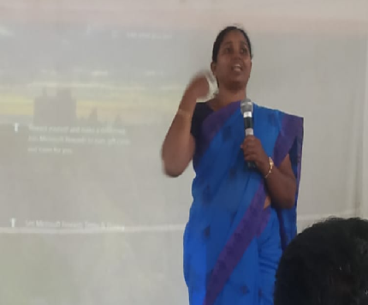

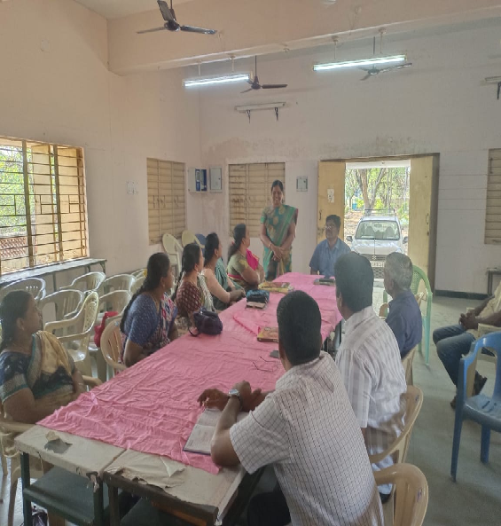

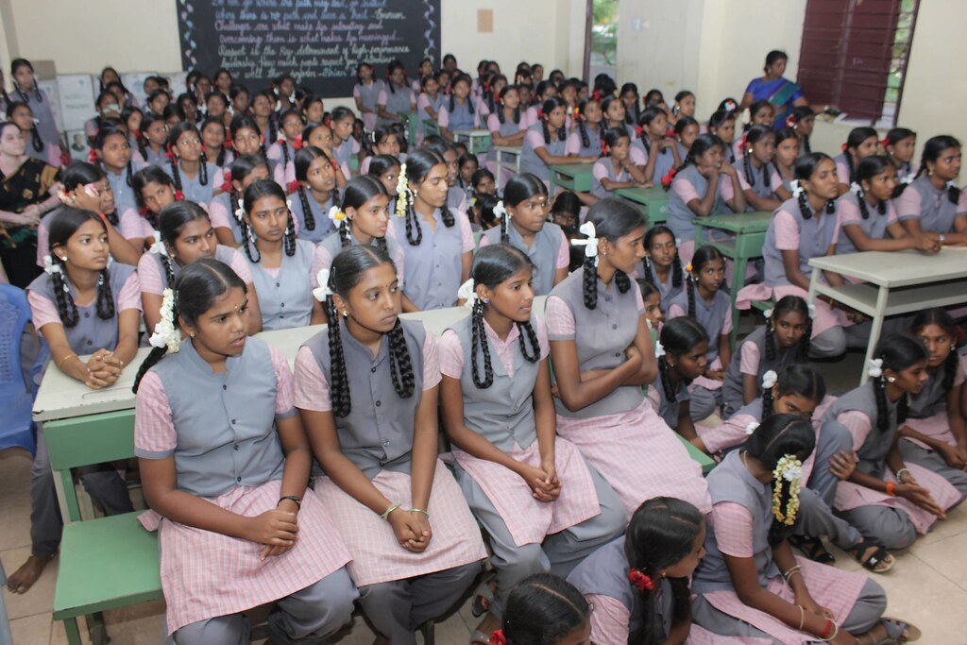

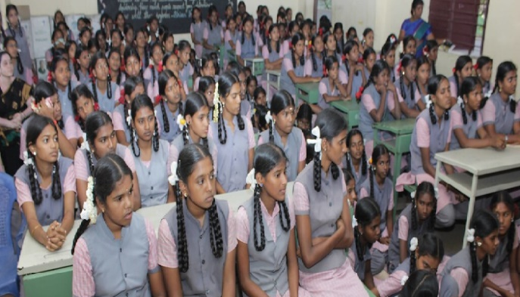

Module

Educating Professional Opportunities among Eklavya School Girls

Module

Investigator
M.Mahalakshmi
Lecturer,
District Institute of Education and Training,
Uthamacholapuram, Salem-10.

Submitted to
STATE COUNCIL OF EDUCATIONAL RESEARCH AND TRAINING, CHENNAI-6.
2023-24
ஏகலைவா பள்ளி மாணவிகள் தொழில்சார் திறனை பெறுவதற்கான சில வழிகாட்டுதல்கள்.

முன்னுரை

பெண்களுக்கு கல்வி கற்பது பொருளாதார, சமூக மற்றும் சுகாதாரத் தரங்களை சாதகமாக பாதிக்கிறது. அதிக பெண் கல்வியறிவு விகிதம் குழந்தை இறப்பைக் குறைக்கிறது. கல்வி குற்றங்களை குறைக்கிறது. பெண் கல்வி சமூகத்தில் சமத்துவமின்மையை குறைக்கிறது.

பெண் கல்வியின் அவசியம்
- பெண் கல்வி என்பது ஒரு சமுதாயத்திற்கு மிகவும் முக்கியமானது என்பதே நம் அனைவரின் கருத்தாகும்.
- ஆண் ஒருவர் கல்வி கற்றால் அவர் ஒருவர் மட்டுமே அறிவு வளர்ச்சி அடைவார். ஆனால், பெண் ஒருவர் கல்வி கற்பதினால் அக்குடும்பம் முழுவதும் கல்வி அறிவு பெறும்.
- எந்த ஒரு நாட்டில் பெண்கள் அதிகமாக கல்வி கற்கிறார்களோ அந் நாடு எப்பொழுதும் சிறந்து விளங்கும் .
- உலகின் மக்கள் தொகையில் சரிபாதியாக விளங்குபவர்கள் பெண்கள். அவர்கள் கல்வி கற்க வேண்டியது அவசியம்.
- ஒரு குழந்தையானது, தனது தாயின் கருவறையிலேயே கல்வி கற்க அரம்பித்து விடுகிறது.
- அக்குழந்தை வளரும்போது அக்கல்வியினை முறையாக பயின்றால் மட்டுமே அக்கல்வி முழுமை அடையும்.
- ஒரு முழுமை அடைந்த கல்வியானது அந்த சமுதாய வளர்ச்சிக்கும், முன்னேற்றத்திற்கும் பெரிதும் உறுதுணையாக இருக்கும்.
பெண் கல்வியின் பயன்கள்
- சமையலறையில் முடங்கிக் கிடந்த பெண்கள் கல்வி கற்றதால் பெண் சமுதாயம் சாதனைகள் பல புரிந்துள்ளது.
- இன்று உலகின் பல்வேறு துறைகளில் பெண்கள் தங்கள் கடமைகளை ஆற்றியுள்ளனர்.
- விளையாட்டு துறை முதல் விண்வெளி ஆராய்ச்சி துறை வரை பல சாதனைகள் புரிந்துள்ளனர்.
- இந்திய சமூகத்தில் பெரும் மாற்றங்களும், சிந்தனைகளும் மற்றும் புரட்சிகளும் ஏற்படுவதற்கு பெண் கல்வி முக்கியத்துவம் வாய்ந்ததாக கருதப்படுகிறது.
- நாமும், வீடும் மற்றும் நாடும் நலம் பெறவும், வளம் பெறவும், ஒளியோடு விளங்கவும் பெண்கள் கல்வியறிவு பெற வேண்டும்.
ஆங்கிலேயர் ஆட்சியில் பெண் கல்வி:
- நம் நாட்டின் விடுதலைக்கு முன்பாகவே அனைவருக்கும் கல்வி வழங்கவேண்டும் என்ற சிந்தனை வலுப்பெற்றுவிட்டது.
- 1854 - இல் சார்லஸ் வுட் என்பவர் (பிரிட்டிஷ்-கிழக்கு இந்திய கம்பெனி தலைவர்)
- சார்லஸ் வுட் டெஸ்பாட்ச் என்ற பெயரில் வழங்கிய அறிக்கை.
- இந்தியாவில் உள்ள அனைத்து ஆரம்ப பள்ளிகளிலும் ஆங்கிலம் பேசும் மொழியாகவும் பாடத்திட்ட மொழியாகவும் நடைமுறைப்படுத்துவதற்கு அறிக்கையை சமர்ப்பித்தார்.
- சார்லஸ் வுட் அதிகார பூர்வமான அறிக்கையை டல்ஹவுஸ்ஸிக்கு அனுப்பிவைத்தார். (கவர்னர் ஜெனரல் ஆப் இந்தியா - டல்ஹவுஸ்ஸி)
பெண் கல்வி சாதனையாளர்கள் :-
Dr.முத்துலட்சுமி ரெட்டி
- டாக்டர் முத்துலட்சுமி ரெட்டி (1886 - 1968) அவர்கள், தமிழ்நாட்டில் மதராஸ் மருத்துவ கல்லூரியில் மருத்துவப் படிப்பில் பட்டம் பெற்ற முதல் பெண் மருத்துவர்ஆவார்
- இவர் 1912 ஆம் ஆண்டு சென்னை மருத்துவக் கல்லூரியில் இருந்து பட்டம் பெற்று மருத்துவச் சேவையாற்றினார்.
- இந்தியாவின் பெண் மருத்துவர், சமூகப் போராளி, தமிழார்வலர்.JULY-22, 1968)
- இவர் இந்தியப்பெண்கள் சங்கத்தின் முதல் தலைவராக பணியாற்றினார்.
- அடுப்பூதும் பெண்களுக்கு படிப்பு எதற்கு என்ற பழைய பஞ்சாங்கம் கோலோட்சிய அந்தக் காலக் கட்டத்தில், எதிர் நீச்சல் போட்டு 4 வயதில் திண்ணைப் பள்ளியில் தொடங்கி, தனது பள்ளிப்படிப்பை முடித்து, கல்லூரியில் பயில விரும்பிய முத்துலட்சுமிக்கு அவரது தந்தை ஊக்கமளித்தார்.
- 1907 -ல் சென்னை மருத்துவக் கல்லூரியில் சேர்ந்த நாட்டின் முதல் பெண்ணான முத்துலட்சுமி படிப்பில் சிறந்து விளங்கி, ஒவ்வொரு ஆண்டும் சிறப்புச் சான்றிதழ்களும், தங்கப் பதக்கங்களும் பெற்றார்
- 1912-ல் நாட்டின் முதல் பெண் மருத்துவர் என்ற பெருமையைப் பெற்றார்.
- சென்னை மாநகராட்சியின் முதல் துணை மேயர் என்னும் பெருமையும் இவருக்கு உண்டு.
- அன்றைய சென்னை மாகாண சட்டசபைக்கு முத்துலட்சுமி தேர்ந்தெடுக்கப்பட்டார். அதன் மூலம் சட்டமன்றத்துக்குத் தேர்ந்தெடுக்கப்பட்ட முதல் பெண்மணி என்ற பெருமை பெற்றார்.
- 1925-ஆம் ஆண்டு சட்டசபைத் துணைத்தலைவராக போட்டியின்றி தேர்ந்தெடுக்கப்பட்டார்.
- இந்தப் பதவியில் இருந்த ஐந்தாண்டுளில் சில புரட்சி சட்டங்களைக் கொண்டு வந்து நிறைவேற்றினார். அவற்றில், தேவதாசி முறை ஒழிப்பு, இருதார தடைச் சட்டம்,பெண்களுக்குச் சொத்துரிமை வழங்கும் சட்டம், பால்ய விவாகங்களை தடை செய்யும் சட்டம் போன்ற சில குறிப்பிடத்தக்கவை.
- முத்துலட்சுமியின் சேவைகளுக்காக மத்திய அரசு 1956 இல் பத்ம பூஷன் விருது கொடுத்து கௌரவித்தது

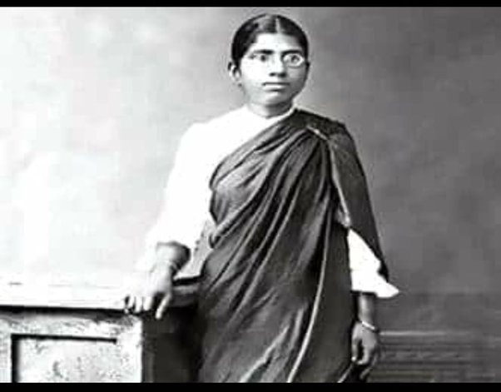
முனைவர் கலைச்செல்வி
- டாக்டர் என். கலைச்செல்வி அவர்கள் 75 வருட சுதந்திர இந்தியாவின் முதல் பெண் தலைமை இயக்குநராக (பொது) (CSIR & DSIR) 2022ஆம் ஆண்டு புதுடெல்லியில் பதவியேற்றார். COUNCIL OF SCIENTIFIC & INDUSTRIAL RESEARCH(CSIR) & DEPARTMENT OF SCIENTIFIC & INDUSTRIAL RESEARCH(DSIR)
- அவர் 25 வருடத்திற்கு மேலாக எலக்ட்ரோ கெமிக்கல் பவர் சிஸ்டத்தில் ஆராய்ச்சி செய்தார். இவர் லித்தியம் பேட்டரி( Lithium Battery) துறையில் சிறப்பு ஆராய்ச்சிகளை மேற்கொண்டுள்ளார்.
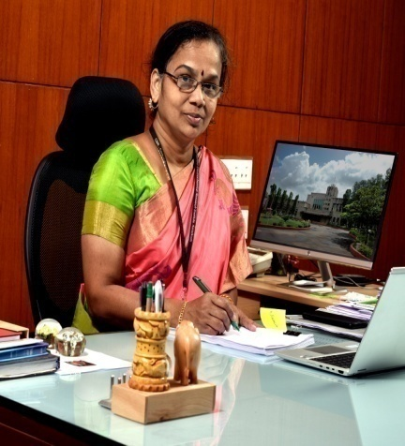

இந்தியாவின் முதல் பெண் கல்வி புரட்சியாளர்
சாவித்திரிபாய் புலே-முதல் பெண் ஆசிரியை
- பெண்களின் கல்விக்காக அறிய பல சாதனைகளைப் படைத்தவர் சாவித்திரிபாய் புலே.
- அவர் தன் கணவர் ஜோதிராயுடன் இணைந்து பெண்களுக்கான தனிப் பள்ளியை புனேயில் 1848 இல் நிறுவினார்.
- இந்தியாவில் பெண்களுக்கான முதல் பள்ளி என்ற சிறப்பு ,அப்பள்ளிக்கும் முதல் பெண் ஆசிரியர் என்ற புகழ் அவருக்கு கிடைத்தன.
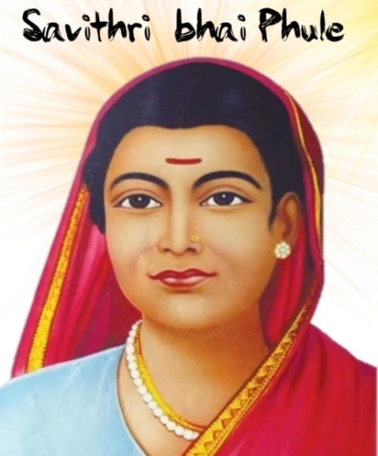
இந்தியாவில் முதன் முதலில் 1883 ஆம் ஆண்டு மேற்கு வங்கத்தை சேர்ந்த சந்திரமுகி பாசு மற்றும் காதம்பின் கங்குலி ஆகிய இருவர் பட்டம் பெற்றனர்.
- சந்திரமுகி பாசு கலைப்பிரிவிலும்,
- கங்குலி மருத்துவத்திலும் பட்டம் பெற்றனர்.
- காதம்பின் கங்குலி மருத்துவ மேற்படிப்பிற்காக இங்கிலாந்து சென்று பின்னர் இந்தியாவில் புகழ்பெற்ற மருத்தவராகத் திகழ்ந்தார்.
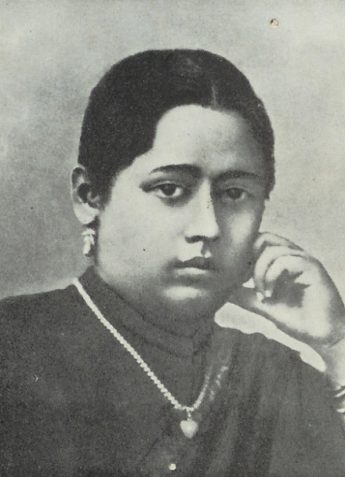
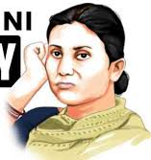
பெண்கள் உரிமை
- பெண்கள் பாதுகாப்பான நிறைவான மற்றும் ஆக்கபூர்வமான வாழ்க்கையை மேற்கொள்ளும் போது, அவர்கள் தங்கள் முழு திறமையை வெளிப்படுத்தி உழைக்கும் மகளிராக திகழ்வதோடு மட்டுமல்லாமல் மகிழ்ச்சியான மற்றும் ஆரோக்கியமான குழந்தைகளையும் உருவாக்குகின்றனர்.
- நாட்டின் பொருளாதார வளர்ச்சி நிலையான அரசியல் மற்றும் சமூக மாற்றம் போன்றவை பெண்களுக்கு அதிகாரம் அளிப்பதனால் ஏற்படுகிறது.
- பெண்கள் ஒவ்வொரு நாளும் பல்வேறு நிலைகளில் அவர்கள் தம் பணியை சிறப்புடன் மேற்கொள்வதால் சமூகத்தின் முதுகெலும்பாக கருதப்படுகின்றனர்.
பெண்களின் சட்ட உரிமைகள்
- இந்திய அரசியலமைப்புச் சட்டத்தின் அடிப்படை உரிமைகளான - சட்டத்தின் முன் அனைவரும் சமம் என்பதையும் அனைவருக்கும் சமமான பாதுகாப்பையும் உறுதி செய்கின்றது.
- இந்திய தண்டனைச் சட்டத்தின் பிரிவு படி பெண்களின் பாதுகாப்பு மற்றும் உரிமைகளை உறுதி செய்யும் பொருட்டு பல்வேறு சட்ட உரிமைகள் வழங்கப்பட்டு வருகின்றது.
- பெண்களின் வாழ்க்கைப் பாதுகாப்புச் சட்டம் மற்றும் திருமணப் பாதுகாப்புச் சட்டம் போன்ற சட்ட உரிமைகளால் பெண்களின் பாதுகாப்பான வாழ்க்கை உறுதிசெய்யப்படுகிறது.
- திருமண தடுப்புச் சட்டம் (2006)
- 2007 ஆம் ஆண்டு பாலியல் குற்றங்களிலிருந்து குழந்தைகளைப் பாதுகாக்கும் சட்டம் பெண் குழந்தைகளுக்காக இயற்றப்பட்டது.
- போக்சோ சட்டம் : ( POCSO-PROTECTION OF CHILDREN FROM SEXUAL OFFENCESS ACT -2012)
- பெண் குழந்தைகள் மற்றும் பெண்கள் பணிபுரியும் இடங்களில் பாலியல் வன்முறைகளிலிருந்து பெண்களை பாதுகாக்கும் சட்டம் ஆகும்.
குழந்தை திருமண தடைச் சட்டம்
- குழந்தை திருமண தடைச் சட்டம் 2006:
இச் சட்டம் குழந்தை திருமணத்தை தடை செய்யவும் பாதிக்கப்பட்டவர்களை பாதுகாப்பாகவும், நிவாரணம் அளித்திடவும் குழந்தை திருமணத்திற்கு உடந்தையாக இருப்பவர்கள் ஊக்குவிப்பவர்கள் மற்றும் நடத்துபவர்களுக்கு கடுமையான தண்டனைகளை உறுதி செய்யவும் உகந்த வழி வகைகளை கொண்டிருக்கிறது குழந்தை திருமணங்களை அறவே ஒழித்திட தமிழ்நாடு குழந்தை திருமண தடுப்பு விதிகள் 2009 மாநில அரசால் உருவாக்கப்பட்டு நடைமுறைப்படுத்தப்பட்டு வருகிறது.
பெண்கள் உரிமை மற்றும் திட்டங்கள்
- பெண் குழந்தைகள் குறைந்தபட்சம் பத்தாம் வகுப்பு வரை கல்வி பெறுவதை உறுதி செய்தல், பின் உயர்கல்வி பெறவும் ஊக்குவித்தல்.
- 21 வயதிற்குப் பிறகு திருமணம் செய்து கொள்ளும் மனப்பான்மையைப் பெண் குழந்தைகளிடம் வளர்த்தல்.
- பெண் குழந்தைகளுக்கு சம அதிகாரம் அளிக்கும் வாய்ப்புகளை குடும்ப உறுப்பினர்களிடையே விழிப்புணர்வு ஏற்படுத்துதல்.
- பெண் குழந்தைகளின் உரிமைகளைப் பாதுகாத்தல் மற்றும் சமூகப் பொருளாதார மேம்பாடு வழங்குதல்.
பள்ளியில் பயிலும்பெண் குழந்தைகளுக்கான கல்வி சார்ந்த அரசு திட்டங்கள்
- முதலமைச்சரின் பெண் குழந்தை பாதுகாப்புத் திட்டம்:
  - 1992 ஆம் ஆண்டு தொடங்கப்பட்டது. பெண் குழந்தைகளின் கல்வியை உறுதி செய்திடவும், மற்றும் அவர்களின் உரிமைகளைக் காத்திடவும் அரசால், குழந்தைகளின் பெயரில் நேரடியாக வைப்பு நிதி முதலீடு செய்யும் திட்டம் அறிமுகப்படுத்தப்பட்டது.
  - இத்திட்டத்தின் கீழ் ஒரு குடும்பத்தில் ஒரு பெண் குழந்தை மட்டும் பிறந்து இருப்பின்குழந்தையின் பெயரில் நிலையான வைய்ப்புத்தொகையாக ரூபாய் 50, 000 தமிழ்நாடு மின்விசை நிதி மற்றும் அடிப்படை வசதி மேம்பாட்டுநிறுவனத்தில் முதலீடு செய்யப்படுகிறது.
  - இந்த வைப்புத்தொகையின் இரசீது நகல் பெண் குழந்தையின் குடும்பத்திற்கு வழங்கப்படுகிறது.
திட்டம் 2:
- இத்திட்டத்தின் கீழ் ஒரு குடும்பத்தில் இரண்டு பெண் குழந்தைகள் மட்டும் இருக்கும் பட்சத்தில் ஒவ்வொரு பெண் குழந்தையின் பெயரிலும் நிலையான வைப்புத் தொகையாக தலா ரூபாய். 25,000/- (இருபத்து ஐந்தாயிரம்) தமிழ்நாடு மின்விசை நிதி மற்றும் அடிப்படை வசதி மேம்பாட்டு நிறுவனத்தில் முதலீடு செய்யப்படுகிறது.
திட்டம் (3)
- 2022 – 2023 ஆம் கல்வியாண்டில் ஆறாம் வகுப்பு முதல் 12 ஆம் வகுப்பு வரை அரசு பள்ளிகளில் படிக்கும் மாணவிகளுக்கு உயர்கல்வி பெறுவதற்கான வாய்ப்பினை உருவாக்கி மேற்படிப்பைத் தொடர்ந்து படித்து பயனடையும் நோக்கில் தமிழக அரசு மூவலூர் இராமாமிர்தம் அம்மையார் உயர்கல்வி உறுதித்திட்டம் “ புதுமைப்பெண் “ என்ற பெயரில் மாதம் ரூபாய் ஆயிரம் வழங்கப்படுகிறது.
- இத்திட்டம் பெண் குழந்தைகளின் உயர் கல்வியை ஊக்கப்படுத்துவதற்கான ஒரு முன்னோடி திட்டம். அரசு பள்ளிகளில் பயிலும் பெண் குழந்தைகளின் எண்ணிக்கையை அதிகரிக்கச் செய்யும். மேலும் இதனால் நல்லறிவு பெற்ற திறனுள்ள சமுதாயம் இந்நாட்டில் உருவாகும் என்பதில் எவ்விதமான ஐயமும் இல்லை.
மகளிர் இலவச பயண பேருந்து திட்டம்
- பணிபுரியும் மகளிர், உயர்கல்வி பயிலும் மாணவிகள் உட்பட அனைத்து மகளிர்களின் பாதுகாப்பான பயணத்தினை உறுதி செய்யும் வகையில் தமிழ்நாடு அரசு போக்குவரத்துக் கழக கட்டுப்பாட்டில் இயங்கும் “சாதாரண கட்டணம்” நகர பேருந்துகளில் கட்டணமில்லா பயணம் செய்யும் வசதி ஏற்படுத்தப்பட்டுள்ளது.
திருமண நிதி உதவி திட்டம்
- ஈ. வே. ரா. மணியம்மையார் நினைவு - விதவை மகள் திருமண நிதி உதவி திட்டம் மற்றும் அன்னை தெரசா அம்மையார் நினைவு ஆதரவற்ற பெண் திருமண நிதி உதவி திட்டமாக எட்டு கிராம் தங்க நாணயத்துடன், பட்டம் பெற்றவர்களுக்கு ரூ. 50,000, (ஐம்பதாயிரம் மட்டும்) மற்றவர்களுக்கு ரூ. 25,000/- (இருபத்து ஐந்தாயிரம் மட்டும் ) நிதி உதவிகள் வழங்கப்பட்டு வருகிறது.
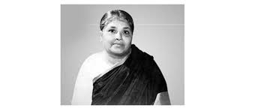
டாக்டர் தர்மாம்பாள் அம்மையார் நினைவு – விதவை மறுமண நிதி உதவி திட்டம் மற்றும் டாக்டர் முத்துலட்சுமி ரெட்டி நினைவு – கலப்பு திருமண நிதி உதவி திட்டங்களின் கீழ் எட்டு கிராம் தங்க நாணயத்துடன் பட்டதாரி அல்லாதவருக்கான நிதி உதவி தொகையான ரூ.25,000 / - ல் ரூ.15,000 / - மின்னணு பரிமாற்றம் மூலமாகவும் மற்றும் தேசிய சேமிப்பு பத்திரமாக ரூ 10,000 மற்றும் பட்டம் பெற்றோருக்கான நிதி உதவி தொகை ரூ. 50,000/ - இல் மின்னணு பரிமாற்றம் மூலம் ரூ. 30,000/- மற்றும் தேசிய சேமிப்பு பத்திரமாக ரூ. 20,000 /- வழங்கப்படுகிறது .
தமிழக அரசு மகளிர் மேம்பாட்டுத் திட்டங்கள் :
- சத்தியவாணி முத்து அம்மையார் நினைவு இலவச தையல் இயந்திரம் வழங்கும் திட்டம்.
- சமூகத்தில் பெண்களின் நிலையை உயர்த்திட குறிப்பாக பொருளாதாரத்தில் நலிவுற்ற பெண்கள் மற்றும் கணவனால் கைவிடப்பட்ட பெண்களின் வாழ்க்கை தரத்தை உயர்த்திக் கொள்ளும் வகையில் அவர்கள் சுயமாக தொழில் புரிந்து, அவர்களின் வாழ்வாதாரத்தை பூர்த்தி செய்து கொள்ள இந்த திட்டம் பெரும் உதவியாக அமைகிறது.
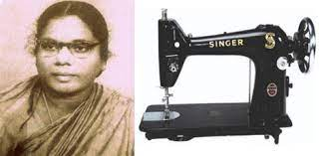
- அரசு சேவை இல்லங்களில் பன்னிரண்டாம் வகுப்பு வரை படித்து முடித்த பெண் குழந்தைகள் உயர்கல்வி பயில்வதை ஊக்கப்படுத்திடும் வகையில் தொழில்சார் கல்வி பயில ரூ 50,000 மற்றும் பட்டப்படிப்பு படித்திட ரூ 30,000 நிதி உதவி அரசால் வழங்கப்பட்டு வருகின்றது.
மகளிர் பாதுகாப்புத் திட்டங்கள்:
- குறுகிய கால தங்கும் இல்லம்:
இத்திட்டமானது இக்கட்டான சூழ்நிலையில் உள்ள பெண்களுக்கு மறுவாழ்வு அளிக்கும் நோக்கத்துடன் தங்குமிடம், உணவு, உடை, ஆலோசனை மற்றும் சட்ட உதவி போன்றவைகளை வழங்குகிறது.
- தன்னார்வ தொண்டு நிறுவனங்களால் நடத்தப்படும் ஒரு குறுகிய கால தங்கும் இல்லத்தில் 30 பெண்கள் அதிகபட்சம் ஐந்தாண்டுகள் வரை தங்கலாம்.
- 60 வயதுக்கு மேற்பட்ட பெண்கள் முதியோர் இல்லங்களுக்கு மாற்றப்படுவார்கள், இந்த இல்லங்களில் 12 வயது வரை ஆண் குழந்தைகளும் 18 வயது வரை பெண் குழந்தைகளும் தங்கள் தாயுடன் தங்கி பயனடையலாம்.
மகளிர்சக்தி மையம்:
- மகளிர் சக்தி மையம் என்னும் திட்டம் ஒன்றிய அரசால் 2017-18 ஆம் ஆண்டில் அறிமுகப்படுத்தப்பட்டது.
- கிராமப்புற மகளிர் மேம்பாட்டிற்காக அரசு நலத்திட்டங்கள், திறன் பயிற்சிகள், அடிப்படை சட்ட உதவிகள், கல்வி அறிவு, சுகாதாரம் மற்றும் ஊட்டச்சத்து குறித்து விழிப்புணர்வு நிகழ்ச்சிகளை மகளிர் சக்தி மையம் மேற்கொண்டு வருகிறது.
மகளிர் உதவி எண் – 181
- 2018, நவம்பர் முதல் ஒன்றிய அரசின் 100% நிதி உதவியுடன் நாடு முழுவதும் ஒரே சீரான மகளிர் உதவி எண் - 181 ஏற்படுத்தப்பட்டுள்ளது.
- வன்முறையால் பாதிக்கப்பட்ட பெண்களின் 24 மணி நேர உடனடி மற்றும் அவசர தொலைபேசி அழைப்பினை ஏற்பதே இத் திட்டத்தின் நோக்கம் ஆகும்.
மகளிர்க்கான ஒன்றிய மற்றும் மாநில அரசு விருதுகள்
- அவ்வையார் விருது - சமூக சீர்திருத்தம், மகளிர் மேம்பாடு, மத நல்லிணக்கம், கலை, அறிவியல், பண்பாடு, கலாச்சாரம், பத்திரிக்கை மற்றும் நிர்வாகம் உள்ளிட்ட பல்வேறு துறைகளில் மிகச் சிறந்து விளங்கும் மகளிருக்கு சர்வதேச மகளிர் தினமான மார்ச் 8-ஆம் தேதி அன்று ஒவ்வொரு ஆண்டும் மாநில அரசால் அவ்வையார் விருது வழங்கப்பட்டு வருகிறது.
- அவ்வையார் விருது பெறுபவர் எட்டு கிராம் தங்கப் பதக்கம், ஒரு இலட்சம் ரூபாய்க்கான காசோலை மற்றும் சான்று ஆகியவை வழங்கி கௌரவப்படுத்தப்படுகிறார்கள்.
பெண் குழந்தைகளின் முன்னேற்றத்திற்கான விருதுகள்
- தமிழ் நாடு அரசால் தேசிய பெண் குழந்தைகள் தினமான ஜனவரி 24-ஆம் தேதி ஒவ்வொரு ஆண்டும் 5 வயதிற்கு மேல் 18 வயதுக்கு உட்பட்ட தமிழக, பெண் குழந்தைகளின் சமூக முன்னேற்றத்திற்கு ஆற்றிய வீர தீர செயல் மற்றும் சாதனைகளுக்காக மாநில அரசின் விருதாக ரொக்க பரிசு ரூபாய் ஒரு இலட்சத்திற்கான காசோலையும், பாராட்டுப் பத்திரமும் வழங்கப்படுகிறது.
PG Scholarship for SC/ST Students for Pursuing Professional courses (PGSPROF)
The scheme has been initiated to provide opportunity to the deprived sections of the society, viz. the Scheduled Caste (SC) and Scheduled Tribe (ST) for undertaking postgraduate level studies in Professional subjects like Engineering & Technology, Management, Pharmacy etc. in recognized Indian Universities/ Institutions. This scheme aims to provide financial assistance to 1000 SC/ST candidates every year.
Eligibility:
- The candidate must have obtained Graduate degree in the relevant subject and obtained admission at Postgraduate level for regular full-time course in any of the Professional subject in a recognized University/Institution/College.
- ii) The upper age limit for 45 and 50 years for male and female applicants respectively. In exceptional cases, the age may be relaxed. Fellowship amount: A scholarship amount of Rs.7800 p.m. to ME/M.Tech students while Rs.4700 p.m. to those pursuing other courses is given. Annual Contingency of Rs.15000 for ME/M.Tech.students while that of Rs.10000 for other courses is also provided. The tenure of fellowship is for two/three years, depending upon tenure of the postgraduate course.
The Best Job Opportunities for Women
- Teacher/ Education Expert
- Teaching is a popular career option for women in India. First, because it provides a degree of flexibility that might suit your lifestyle. School hours often align with family schedules, providing some work-life balance.
- The presence of fixed leaves and limited working hours also makes it a popular career choice for women.
- Another reason why teaching is popular is that it offers the chance to shape future generations and create a profound impact on society.
- Many women also take up part-time teaching options, either through tuitions at home or by taking up classes at coaching centers.
Human Resource Management
- The Human Resource team is central to any organisation. This team is responsible for recruiting, managing, training, and helping the personnel of an organization.
- In the past few years, this sector has seen immense growth and has become one of the best career options for women with good interpersonal skills.
- If you are good with people, have attention to detail, and possess great communication skills, HR is among the good career choices for women.
- It is a high-paying job and provides a fulfilling career path. You can pursue Bachelors and Masters’ in Human Resource Management to make a career in this field.

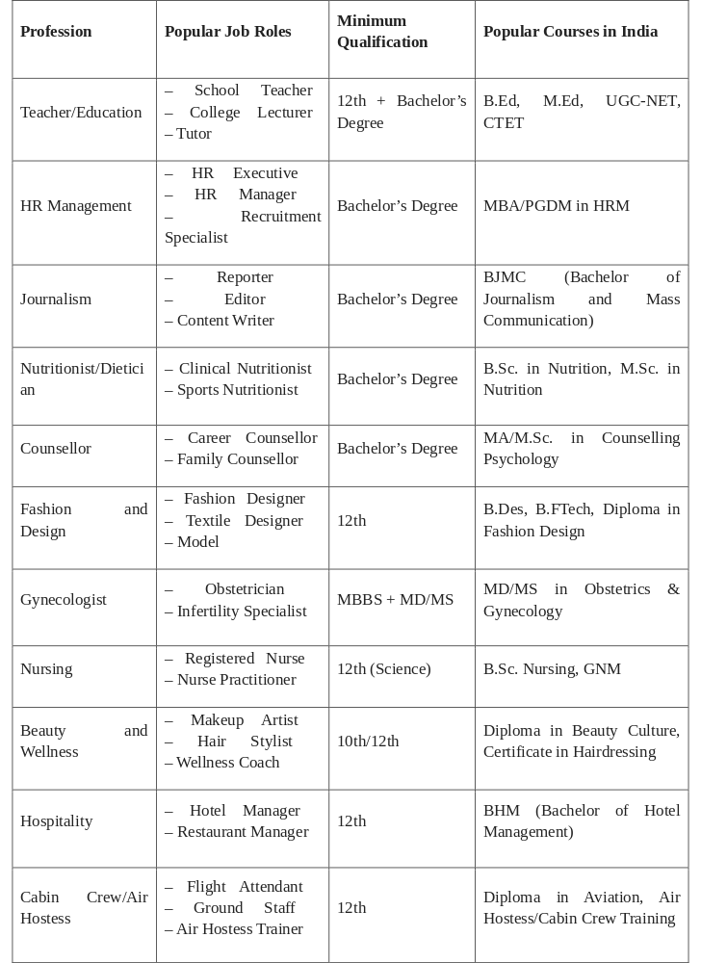
Journalism
Journalism has seen many exemplary women over the years, with many reporters making a name for themselves. After completing a journalism course, you can work in media houses, publishing houses, or practice independent journalism. Journalists play an important role in shaping public opinion, which makes it an attractive career option.
It’s also a very exciting and dynamic job, appealing to those energetic, driven individuals and those who thrive on variety. All of these make it a good career to join after college. You can work as a writer, editor, journalist, reporter, or research analyst. The scope of work and career growth is immense in this field.
Nutritionist
The job role of nutritionist or dietician is popular among women, because the field of dietetics was heavily marketed towards women. The success of role models like Ishi Khosla, Shikha Sharma, and Rujuta Diwakar has also popularized the field among women.
But with an increase in awareness of health and fitness among all sections of society, the demand for nutritionists has increased rapidly. This has made it a top career choice for women.
As a nutritionist, you can provide diet charts, health tips, and fitness regimes to your clients. You can work in a hospital, fitness center, or open your clinic. You can pursue this career after college by doing a bachelor’s in nutrition.
There are diploma courses also available to become a nutritionist. Earnings can be very good and are directly proportional to the success of your practice.
Counsellor
The role of a counsellor requires a high level of emotional intelligence. Since women are traditionally believed to be more empathetic, caring, and good listeners, the role of psychological counsellors has shown a preference for women. This is one reason it was considered among the good career options for women. That said, in India, the demand for counselling services is increasing. This is because people are becoming better aware of mental health issues and are accepting counselling as therapy.
Within counselling, you can choose to be a career counsellor, family counsellor, life coach, or advisor. You can work with counselling clinics, NGOs, or practice privately. With enough work experience, it is among the best paying jobs for women.
Fashion industry
Like the beauty industry, the fashion and design industry has been heavily marketed towards women for decades. The fashion industry has also offered women great economic opportunities. Fashion and Design are an integral part of every woman’s life. If you are creative and passionate about fashion, you can choose to become a Fashion Designer. There are many career options in this industry for you. You can become a designer, textile designer, or even a model.
You can also set up your boutique and build your clientele. Pursuing a course in fashion design will help you gain knowledge and exposure to the fashion industry.
Gynecology
Gynecology is another profession that shows a preference for women practitioners. As the patients are women themselves, they are often more comfortable with female gynecologists. Many women also prefer discussing intimate health issues with female practitioners.
Though it takes some intense effort, once you are well established, it can be a well-paying job. Like any medical practitioner, the profession can be demanding. But you also get the satisfaction of working to improve women’s health. This makes it a top career choice for females.
You can work in a hospital, medical institute, or privately in your clinic. You can work as a general gynecologist or develop specializations to focus on Obstetrics (focus on pregnancy and childbirth) or even Pediatric Gynecologist (Focus on the care of children and teenagers).
Nursing
Nursing has traditionally been a women-dominated profession. That is because women traditionally took on caregiving roles in families. Women were also thought to naturally possess many of the qualities associated with nursing — being compassionate, patient, and understanding. In recent times, many men have also been joining the profession, breaking the stereotype of nursing as a female-only profession.
There are also many women-only nursing colleges, making it easy for females to enter the profession. There is also a huge demand for female nurses, not just in India but also abroad. This makes it a top career option for women.
As a nurse, you need to attend to patients, take care of their needs, and monitor their health. You can undergo a course in nursing before applying for this job position. Then, with time and experience, you can grow in this career path.
Beauty and Wellness
Society has traditionally focused on the importance of appearance for women more than men. The beauty and wellness industry is also mainly aimed at women. So job roles like being a makeup artist have employed more women than men. However, many men and non-binary folks have gained popularity on social media, breaking the gender stereotypes of the beauty industry. However, the beauty industry can be one of the best career options for women.
You can become a hair stylist, nail technician, makeup artist, wellness coach, or even a personal trainer. Many women have found success by becoming beauty Bloggers/Vloggers as well. You can initially practice under a successful makeup artist to learn and gain experience. Later, you can become an independent makeup artist. You can start this career after college as well. Your earnings may vary according to your skills. As you gain more experience over time, you can demand a higher fee from your clients.
Hospitality
In India, women have traditionally been associated with roles involving hospitality, care, and service, which is why the hospitality industry often favors women. Women are also perceived to possess better communication/interpersonal skills and etiquette. Many job roles in hospitality offer flexible working hours, decent pay, and a safe work environment. Because of these factors, most people consider this the best career option for women.
The potential for career growth and global exposure also makes this a good career option for women.
If you’re interested in working in a hotel or restaurant, you can pursue a hotel management course after completing your 12th class. After gaining experience, you can even venture into running your own hotel or restaurant.
Airline Industry
Historically, the role of Cabin Crew or Air Hostess was viewed as glamorous. It also offered a certain social status, especially since it was a well-paying job for women in India. The added benefit of traveling both domestically and internationally was a bonus. After working as a cabin crew for eight to ten years, there are opportunities to transition into airport management or even become an air hostess trainer.
To become an air hostess, it’s necessary to enroll in a training course offered by various academies. Job responsibilities primarily include assisting and taking care of flight passengers.
Banking
The banking sector remains a popular job choice for both men and women in India. Banks offer stable jobs with clear growth opportunities, fixed working hours, and leaves. It’s a prestigious profession in India.
Inspirational women like Arundhati Bhattacharya, Renu Sud Karnad, Shanti Ekambaram, and Shyamala Gopinath have achieved notable success in the financial sector.
To work in banking, clearing various exams conducted nationwide is a prerequisite. After clearing these exams, one can work in either government or private banks. It remains a successful career option for women.
Business Management
Once a field dominated by men, business management is increasingly seen as a career of choice for many women. The success of entrepreneurs like Falguni Nayar, Kiran Mazumdar Shaw has popularized business management roles.
The increased visibility of women in leadership positions is also breaking the glass ceiling for women here.
As a career option for women, it provides upward mobility and a change to bring about change. There are roles in various departments like Sales, Finance, Marketing, and Human Resources. The salaries are also quite competitive. While there are many benefits, you can face some challenges too. This includes navigating traditionally male-dominated corporate hierarchies and maintaining a work-life balance. Getting a Master’s in Business Administration is the best way to break into the field.
Law
Women have been making significant strides in the field of law, showcasing their skills in defending and advocating for people’s rights. The legal profession is immensely rewarding for those who are driven by justice and representation.
After acquiring a law degree, there’s an opportunity to specialize in diverse areas such as criminal, family, corporate, or civil law. While the profession can be demanding with its long hours and intricate cases, the sense of accomplishment in upholding justice makes it a fulfilling career choice for many women.
Top 10 Best Career Options for Girls
The table given below lists out some of the best career options for girls. We have also provided information about Eligibility and Average Monthly Salary.

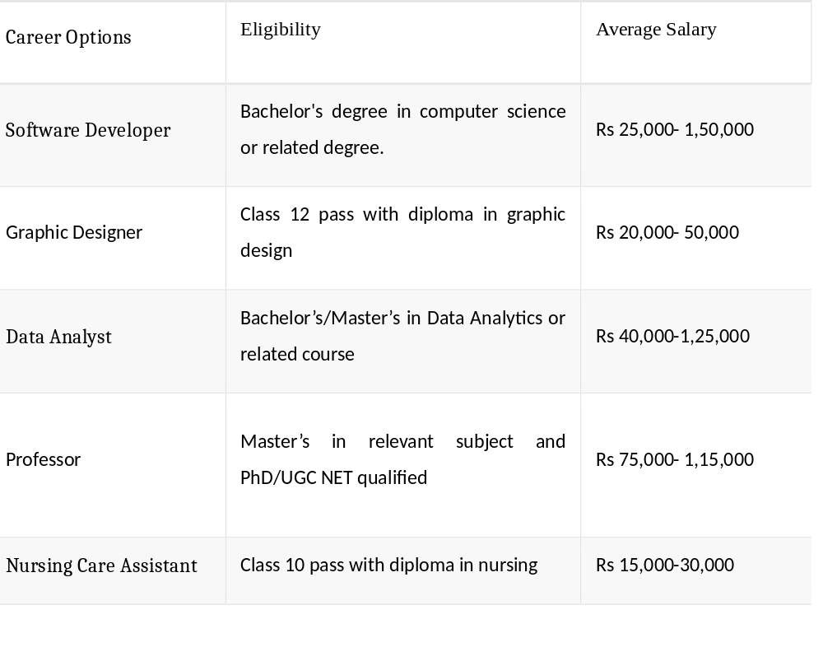

After completing their 12th standard education, there are various schemes and opportunities available for tribal girls in Tamil Nadu to pursue further studies or gain vocational training. Here are some options:
1. Government Scholarships: Tamil Nadu government offers various scholarships for tribal students based on their academic performance. These scholarships can help cover tuition fees, hostel fees, and other educational expenses.
2. Higher Education: Tribal girls can opt for higher education in colleges and universities. They can pursue undergraduate courses in arts, science, commerce, engineering, medicine, etc. They can also pursue postgraduate degrees for further specialization.
3. Skill Development Programs: There are skill development programs initiated by the government and various organizations aimed at empowering tribal youth with vocational skills. These programs offer training in fields such as computer literacy, tailoring, handicrafts, agriculture, etc.
4.Tribal Welfare Department Schemes: The Tribal Welfare Department of Tamil Nadu may offer specific schemes and programs aimed at the educational and economic upliftment of tribal communities. These schemes may include financial assistance, training programs, and other support mechanisms.
5.Entrepreneurship Development: Some initiatives focus on fostering entrepreneurship among tribal youth. This could involve training and support for starting small businesses or enterprises.
6.Specialized Courses: Depending on their interests and aptitude, tribal girls can explore specialized courses like nursing, teaching, paramedical courses, etc., which offer good employment opportunities.
7.Central Government Schemes: There are various schemes initiated by the central government, such as the Pradhan Mantri Kaushal Vikas Yojana (PMKVY), which offers skill development training in various sectors.
8.Non-Governmental Organizations (NGOs): Several NGOs work in Tamil Nadu to provide educational support and skill development training to tribal girls. They offer scholarships, mentoring, and career guidance programs.
Tribal girls in Tamil Nadu have a range of options available to them after completing their 12th standard. It's essential for them to explore these opportunities and choose the path that aligns with their interests and career goals.
In Tamil Nadu, there are several government scholarships available for tribal girls who have completed their 12th standard and wish to pursue higher studies. Some of these scholarships include:
1.Pre-Matric Scholarship for Scheduled Tribes: This scholarship scheme provides financial assistance to ST students studying from Class 1 to 10. It covers admission fees, tuition fees, maintenance allowance, and other incidental expenses.
2.Post-Matric Scholarship for Scheduled Tribes: This scholarship is for ST students studying at the post-matriculation level (Class 11 onwards). It covers tuition fees, maintenance allowance, and other incidental expenses.
3.Merit-cum-Means Scholarship for Professional and Technical Courses CS: This scholarship is for ST students pursuing professional and technical courses at the undergraduate and postgraduate levels. It provides financial assistance to meet tuition fees and maintenance expenses.
4.National Fellowship and Scholarship for Higher Education of ST Students: This scheme provides financial assistance to ST students pursuing higher education such as M.Phil. and Ph.D. It includes fellowships for research and scholarships for tuition fees and incidental expenses.
5.Central Sector Scholarship for College and University Students: This scholarship is awarded to ST students based on their performance in 12th standard exams. It provides financial assistance for undergraduate studies in colleges and universities.
6.Top Class Education Scheme for SC Students: Although primarily for SC students, this scheme may also benefit ST students who are among the top performers in their class 12 examinations. It covers tuition fees, maintenance allowance, and other incidental expenses for professional courses at recognized institutions.
These are some of the prominent government scholarships available for tribal girls in Tamil Nadu after completing their 12th standard and pursuing higher studies. Eligibility criteria, application procedures, and the exact benefits vary for each scholarship, so it's advisable to check with the respective scholarship authorities for detailed information.

In India, several government schemes aim to provide free or subsidized higher education opportunities for tribal girls. While the availability and specifics of these schemes may vary from state to state, here are some overarching initiatives:
1. Post-Matric Scholarship for Scheduled Tribes (ST): This scholarship scheme, provided by the Ministry of Tribal Affairs, Government of India, offers financial assistance to ST students pursuing higher education at the post-matriculation level. It covers tuition fees, maintenance allowance, and other incidental expenses.
2. National Fellowship and Scholarship for Higher Education of ST Students: This scheme is specifically designed to support ST students pursuing higher education such as M.Phil. and Ph.D. It includes fellowships for research and scholarships for tuition fees and incidental expenses.
3. Central Sector Scholarship Scheme for College and University Students: While primarily aimed at economically weaker sections including SC, ST, and OBC students, this scheme also benefits tribal girls based on merit. It covers tuition fees and provides a maintenance allowance for undergraduate studies in colleges and universities.
4. Top Class Education Scheme for SC Students: While primarily for SC students, this scheme may also extend its benefits to meritorious ST students. It covers tuition fees, maintenance allowance, and other incidental expenses for professional courses at recognized institutions.
5. State Government Scholarship Schemes: Many state governments have their own scholarship schemes aimed at supporting higher education for tribal students, including girls. These schemes may offer various forms of financial assistance, including tuition fee waivers, maintenance allowances, and hostel accommodation.
6. Special Initiatives for Girls' Education: Some government schemes specifically target the education of girls from marginalized communities, including tribal girls. These initiatives may offer additional incentives such as free textbooks, transportation allowances, and mentorship programs.
7. Pradhan Mantri Kaushal Vikas Yojana (PMKVY): While not solely focused on higher education, PMKVY aims to provide skill development training to youth, including tribal girls, to enhance their employability. It offers free training programs in various sectors, including healthcare, hospitality, construction, and agriculture.
These are just a few examples of the various free education schemes and scholarships available for tribal girls in India to pursue higher education. Eligibility criteria, application procedures, and benefits may vary, so it's advisable for students to research and inquire about specific schemes available in their state or region.
In Tamil Nadu, several government and non-governmental organizations offer business supporting schemes specifically tailored for tribal women. These schemes aim to empower tribal women economically by providing financial assistance, training, and other forms of support to start and sustain their own businesses. Here are some of the best business supporting schemes for tribal women in Tamil Nadu:
1.National Rural Livelihoods Mission (NRLM): NRLM, also known as Aajeevika, is a centrally sponsored scheme implemented by the Tamil Nadu State Rural Livelihoods Mission (TNSRLM). It focuses on promoting self-employment and entrepreneurship among rural women, including tribal women. NRLM provides financial assistance, skill development training, and support for setting up micro-enterprises through Self-Help Groups (SHGs).
2.Pradhan Mantri Mudra Yojana (PMMY): PMMY aims to provide collateral-free loans to micro-enterprises, including those owned by tribal women, through various financial institutions such as banks, non-banking financial companies (NBFCs), and microfinance institutions (MFIs). The loans under PMMY are categorized into three schemes: Shishu (up to ₹50,000), Kishor (₹50,000 to ₹5 lakh), and Tarun (₹5 lakh to ₹10 lakh).
3.Tribal Development Department Schemes: The Tribal Development Department of Tamil Nadu may offer specific schemes and programs aimed at promoting entrepreneurship among tribal women. These schemes may include financial assistance, training programs, and marketing support for tribal women to start businesses in sectors such as agriculture, handloom, handicrafts, and animal husbandry.
4.State Bank of India (SBI) Sakhi Scheme: SBI Sakhi Scheme is an initiative by the State Bank of India aimed at promoting financial inclusion and entrepreneurship among women, including tribal women, in rural areas. Under this scheme, SBI provides loans and banking services to women entrepreneurs through dedicated Sakhi branches and banking correspondents.
5.Non-Governmental Organizations (NGOs): Several NGOs in Tamil Nadu work towards the economic empowerment of tribal women by providing training, mentorship, and access to microfinance for starting businesses. Examples include organizations like Aide et Action, DHAN Foundation, and M.S. Swaminathan Research Foundation.
6.District Industries Centers (DICs): DICs in Tamil Nadu provide various support services for entrepreneurs, including tribal women, such as assistance in obtaining licenses and permits, access to infrastructure facilities, and guidance on government schemes and subsidies available for starting and running businesses.
7.Tamil Nadu Industrial Guidance & Export Promotion Bureau (TIGPME): TIGPME offers guidance and support to entrepreneurs, including tribal women, in setting up and expanding their businesses. It provides information on government policies, incentives, and schemes available for MSMEs (Micro, Small, and Medium Enterprises).
These are some of the businesses supporting schemes available for tribal women in Tamil Nadu. Each scheme has its own eligibility criteria, application procedures, and benefits, so it's advisable for tribal women entrepreneurs to research and explore the options that best suit their needs and aspirations.
Several NGOs actively support tribal women in Tamil Nadu by providing various services ranging from education and healthcare to livelihood support and empowerment programs. Here are some notable NGOs working in this field:
1.Tribal Health Initiative (THI): THI is based in Sittilingi Valley, Tamil Nadu, and focuses on providing healthcare services to the tribal communities in the region. They run a hospital and community health programs aimed at improving the health and well-being of tribal women and their families.
2.Asha for Education: Asha for Education is a volunteer-driven organization that supports education initiatives for underprivileged children, including tribal girls, across India. They fund projects that provide access to quality education, including scholarships, schools, and vocational training programs.
3.Dharmapuri Outreach (DHAN) Foundation: DHAN Foundation works with tribal communities in Tamil Nadu, including women, to promote sustainable livelihoods, improve access to healthcare and education, and strengthen community institutions. They implement programs focused on agriculture, microfinance, water management, and women's empowerment.
4.Aide et Action: Aide et Action is an international NGO that works in Tamil Nadu to promote education and empowerment among marginalized communities, including tribal women. They run programs to improve access to quality education, vocational training, and livelihood opportunities for tribal women and their families.
5.M.S. Swaminathan Research Foundation (MSSRF): MSSRF works with tribal communities in Tamil Nadu to promote sustainable agriculture, biodiversity conservation, and rural development. They provide training and support to tribal women in organic farming, seed conservation, and entrepreneurship.
6.Rural Development Trust (RDT): RDT operates in Anantapur district of Andhra Pradesh, bordering Tamil Nadu, and works with tribal communities to improve access to healthcare, education, and livelihood opportunities. They run programs focused on women's empowerment, including skill development and self-help groups.
7.The Banyan: The Banyan is a Chennai-based NGO that works with homeless and marginalized populations, including tribal women, who are living with mental health issues. They provide shelter, healthcare, counseling, and rehabilitation services to women in need.
8.Tribal Foundation: Tribal Foundation is dedicated to the welfare and development of tribal communities in Tamil Nadu. They implement programs focused on education, healthcare, livelihoods, and empowerment, with a special emphasis on supporting tribal women and children.
These are just a few examples of NGOs working to support tribal women in Tamil Nadu. Each organization has its own focus areas, programs, and approaches, but they all share a common goal of empowering tribal women and improving their quality of life.
Helen Keller's life story is one of remarkable courage, resilience, and achievement despite facing significant challenges. Born on June 27, 1880, in Tuscumbia, Alabama, Helen Keller was a healthy child until she fell ill with an unknown illness, possibly scarlet fever or meningitis, at the age of 19 months. The illness left her both deaf and blind.
Despite her disabilities, Helen Keller's family sought assistance for her education. At the age of 7, they employed Anne Sullivan, a young teacher, to tutor her. Anne Sullivan's breakthrough moment came when she taught Helen the connection between objects and the letters of the manual alphabet by spelling out "water" while running water over Helen's hand. This momentous event, which occurred at the water pump in the Keller family's garden on March 3, 1887, opened up the world of language and communication to Helen.
With Anne Sullivan's dedicated guidance, Helen Keller made remarkable progress in her education. She learned to read Braille and to write using a specially designed typewriter. She also mastered lip-reading and speaking, despite being unable to hear her own voice.
Helen Keller's thirst for knowledge led her to pursue higher education. She attended Radcliffe College, becoming the first deaf-blind person to earn a Bachelor of Arts degree. Throughout her life, she advocated for the rights of people with disabilities and became a prominent author, lecturer, and activist.
Keller's activism extended beyond disability rights. She was a suffragist, advocating for women's right to vote, and a socialist, supporting various progressive causes such as labor rights and pacifism.
Helen Keller's autobiography, "The Story of My Life," published in 1903, remains a classic portrayal of her journey from isolation to empowerment. She went on to write numerous books, articles, and speeches, sharing her experiences and advocating for social justice.
Helen Keller's legacy continues to inspire millions worldwide. Her indomitable spirit, resilience, and determination serve as a beacon of hope for people facing adversity, demonstrating that with perseverance and support, one can overcome even the most daunting challenges. Helen Keller passed away on June 1, 1968, leaving behind a legacy of courage, compassion, and advocacy.

